**Module- 5**

**Medication errors:**

FDA defines a medication error as any preventable event that may cause or lead to inappropriate medication use or patient harm while the medication is in the control of a healthcare provider, patient, or consumer.

The medication error can be an unintended failure in the drug treatment process that leads to, or has the potential to lead to, harm to the patient.

Before the discussion of the medication error, Reference safety information (RSI) to be discussed.

Reference safety information is the document used to define or explains the type of medication error.

Reference safety information (RSI) is a document maintained by the Marketing authorization holder with a description of the medicinal product.

RSI are:

Investigational brochure (IB)--- Used during clinical trials.

Company core data sheet (CCDS)

Company core safety information (CCSI)—Both are used by MAH for their portfolios.

Summary of product characteristics (SmPC)

Package insert (PI) – Used in Post marketing Authorization

The product information in

Europe--- Summary of product characteristics SmPC

USA----- Package insert PI.

A product to be used in accordance with the product information mentioned in the reference safety information.

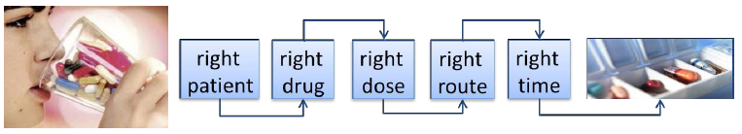

If the product is used which is not in line with the product information in RSI can be considered as medication error.

Medication errors which may be identified in post-marketing use and may frequently arise from the appearance of the product or its labelling are:

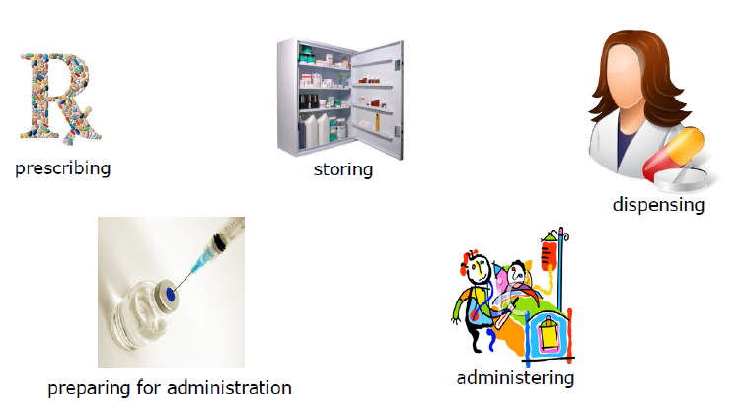

**Prescribing error:**

The prescribing error can be related to

* the correct dose,
* strength of the product use,
* route of administration,
* the length of treatment,
* instructions for dose titration,
* most appropriate dosing time (if applicable)

**Dispensing error:**

Prescriptions are usually dispensed in the hospitals and pharmacies. The errors can be

* selection of the wrong product from the shelf,
* in terms of wrong drug,
* wrong formulation,
* wrong dose or
* wrong strength

**Preparation and administration errors:**

Medicinal products with intravenous (IV) use or parenteral administration require preparation, dilution or reconstitution prior to use ca have a chance of medication errors.

IV administered drugs will have errors of:

* Preparation errors
* Administration errors due to incompatibility with diluents, faster or slower infusion.
* IV drugs can inadvertently given by subsutaneouus route, intradermal route or intramuscular route

Further the errors can be.

* Use of expired medicines
* Overdose of medications-Intentional or accidental overdose.
* Stored at wrong temperature.
* Drugs not received at right time (e.g. on an empty stomach or in the morning rather than in the evening).

Device related medication errors is one of type of medication error, which can be device failure as well.

The Division of Medication Error Prevention and Analysis (DMEPA) within CDER is responsible for monitoring and preventing medication errors related to the naming, labeling, packaging, and design for CDER-regulated drugs and therapeutic biological products.

Classification of Medication errors for simplification and coding:

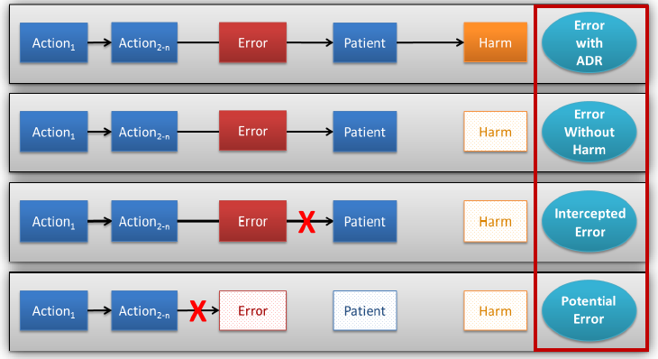

* Case 1. Drug given to the patient and adverse event occurred- medication error with adverse event
* Case 2. Medication error occurred which does not harm the patient.
* Case 3. Medication error occurred while preparing the drug where patient is not involved- called as Intercepted medication error.
* Case 4. Error occurred before the preparation and no patient is involved which can explain as potential mediation error.